Kirtan Patel

CMPSC 487W

Dr.Hien

Project 2 Web app screenshot implementation

**Browse the list of items**.

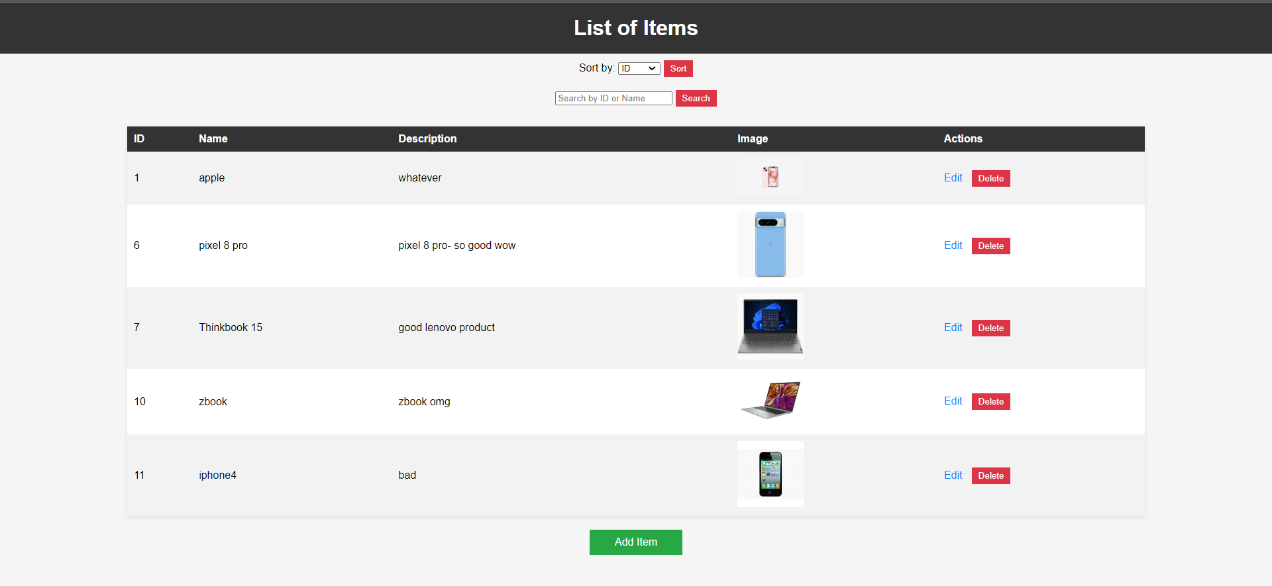

**Sort the list by item ID, or by item name. (general function)**

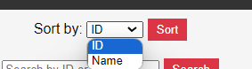

**VIA ID  
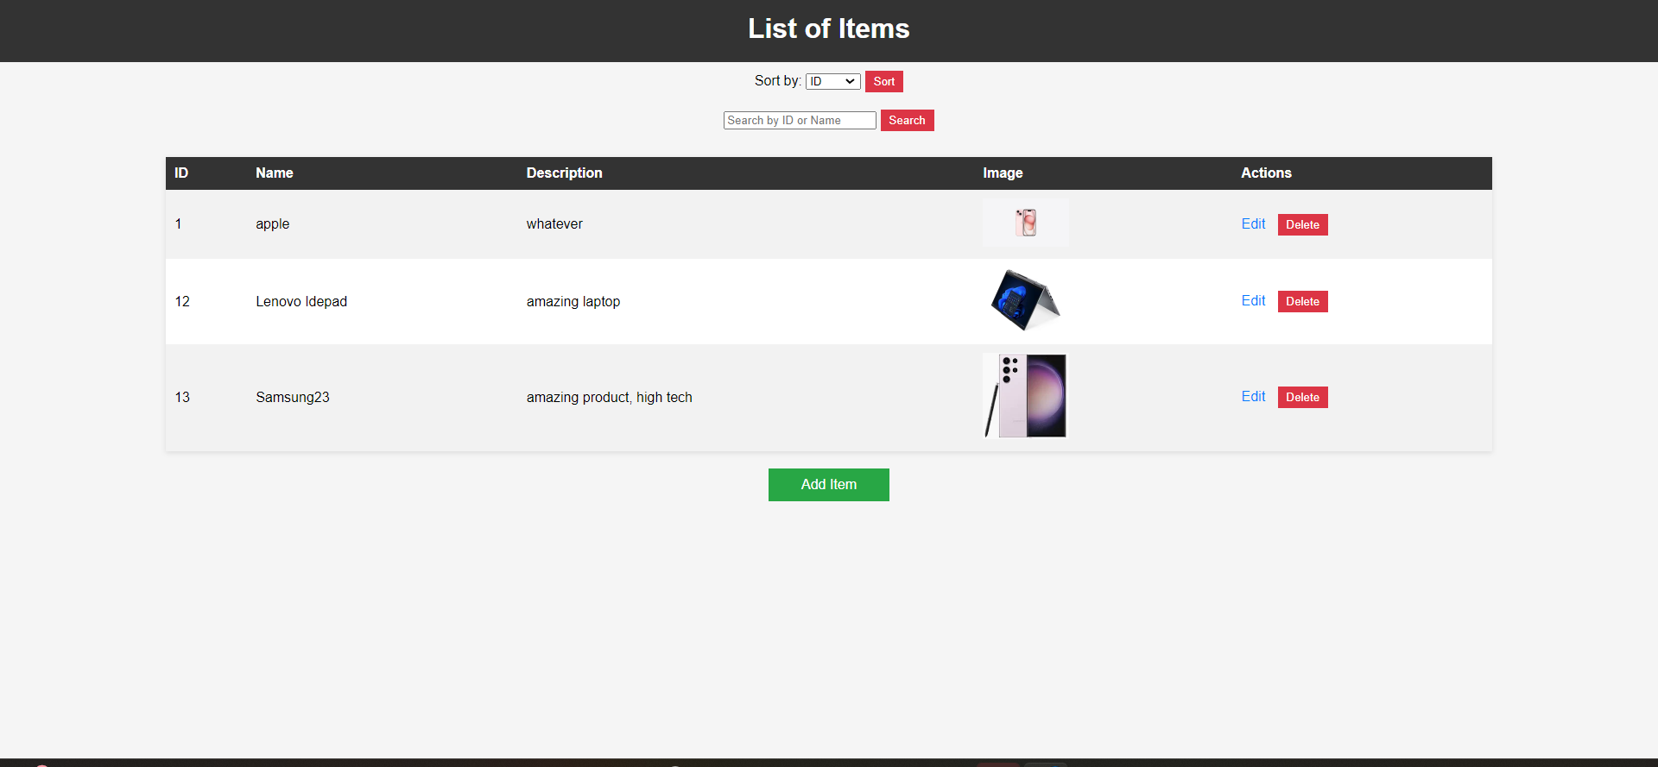**

**VIA name**

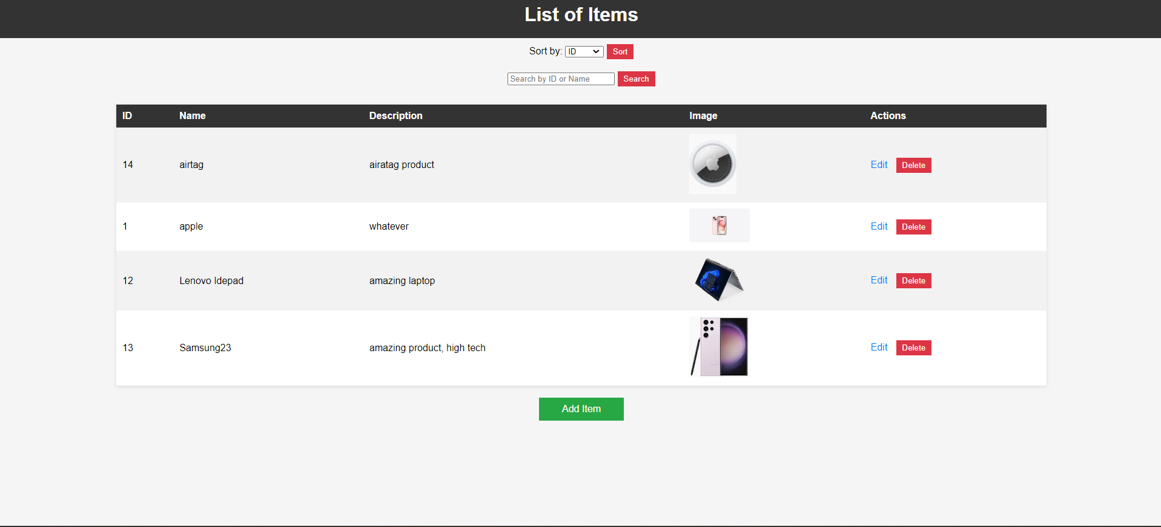

**Search an item by a keyword or by ID. (General functionality)**



**Via ID example**

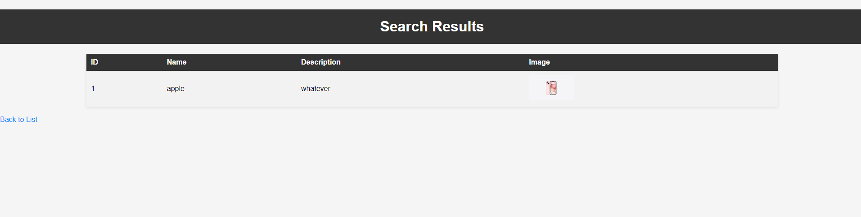

**Via keyword example**

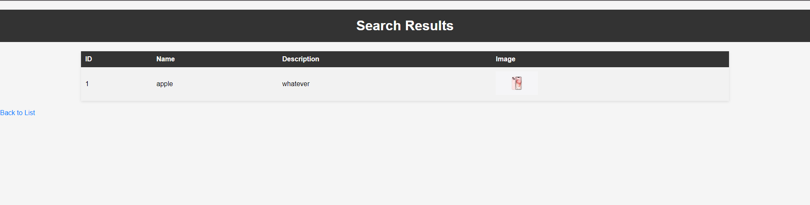

**Add a new item to the list (assuming the ID is auto generated).**

**General button**



**Add item example**

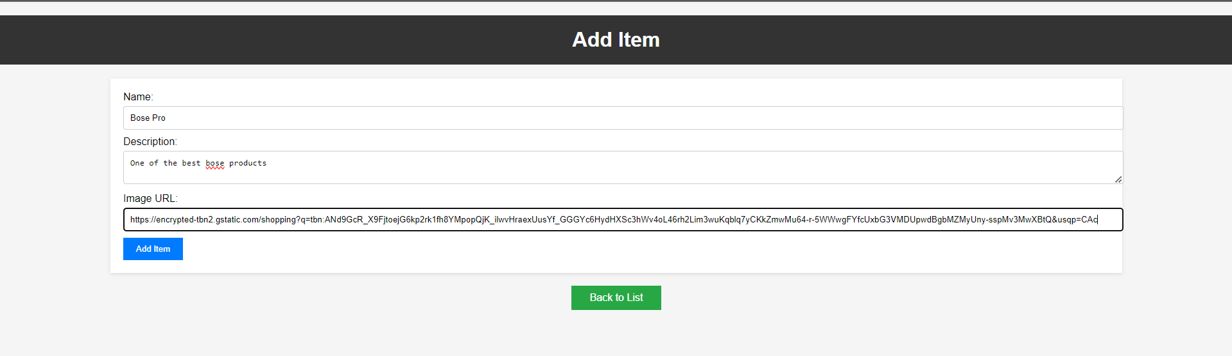



**Select an item to edit (assuming you can edit any attribute except for the ID).**

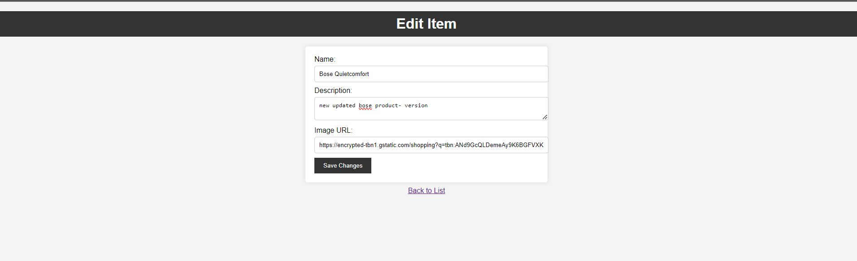

**So I changed the contents of the bose headphones to match the lastest update**



**Remove an item**

**  
  
we would click the delete button**

**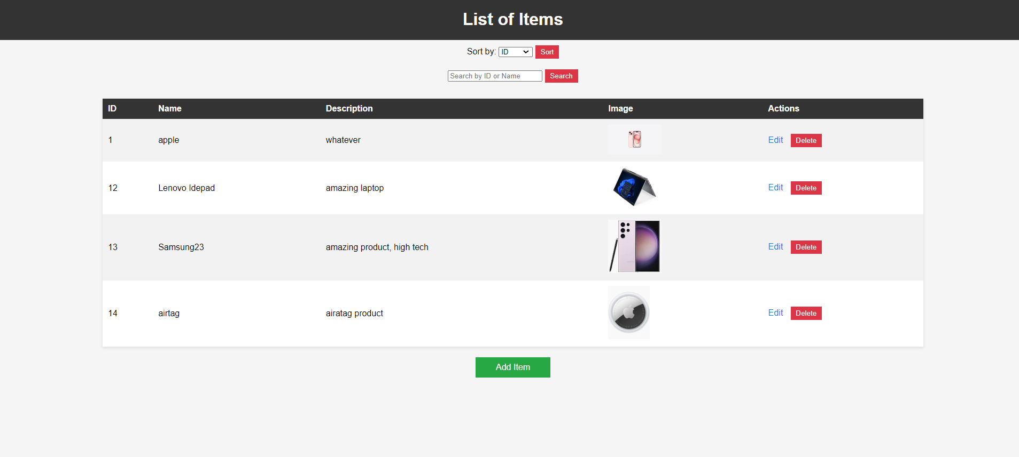  
  
now its gone**